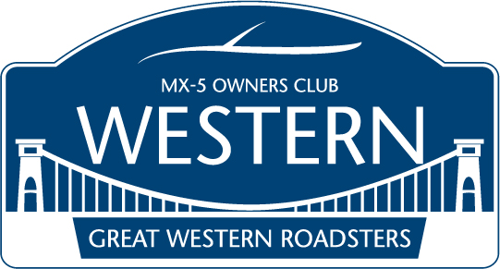

Welcome to the Great Western Roadsters
Grand Tour of Europe 2017

In this short guide, you will find the basic information needed to make your own arrangements should you wish to join us.
I have highlighted Ferry crossings, overnight stays, hotels we shall be staying in and some advice on driving in Europe.
If you choose to join us, take heed, this is a driving holiday.

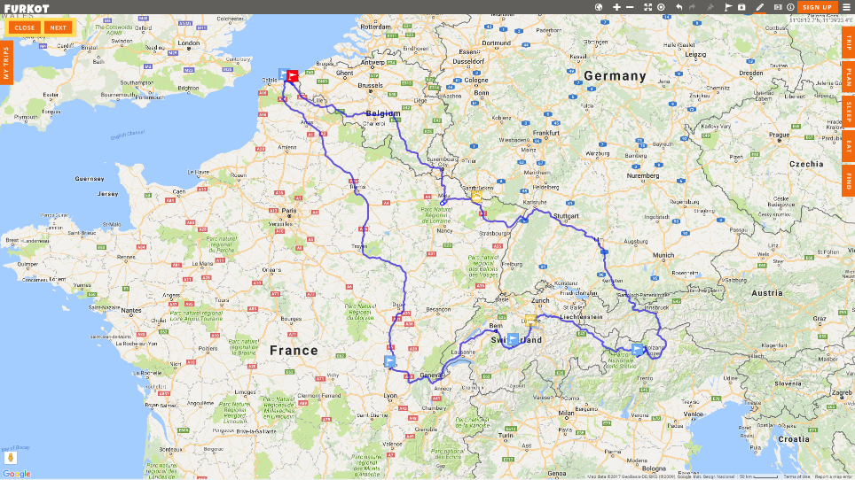
Should you wish to embark on this crazy adventure I have put together ferry times and the hotels we shall be staying in for you to make your own arrangements.
Be warned it is a driving holiday, with up to 10 hours a day in the saddle!

Wednesday 20th September will see us leave from Dover at 1400hrs on the DFDS crossing to Dunkirk.
Arriving in France at 1700hrs local time we shall have a four-hour drive through Belgium, Luxembourg and back into France to the first overnight stop at Augny.
We are staying in the Ibis Budget Metz Zud.

Thursday will be a drive into Germany, through Austria and across the Italian alps into Northern Italy to Ulten. This is approximately an 8 ½ hour drive without stops to get us close to the Stelvio Pass for Friday.
Our lodgings for the night are Hotel Seerast
St. Waldburg 210, 39016 Ultimo.

Friday, we set off for Interlaken, Switzerland taking in the Stelvio Pass in Italy then into Switzerland using the Pass Santa Maria, Pass Zemez and Pass Davos amongst others. A mere 400kms today, but due to the nature of the roads you could be driving 11 hours!
Today’s overnight is in Interlaken at Hotel Blume
Jungfraustrasse 30, 3800 Interlaken

Saturday, we leave Switzerland and head back into France for the accommodation for the night at Macon. Around a 6-hour drive today. Hotel for the night is Brit Hotel Macon Centre Gare.
1 rue Bigonnet, 71000 Macon.

Sunday, we run back up towards Dunkirk, so autoroutes I’m afraid.
We’re heading for a small walled town called Bergues and some fancy hotel I’ve had the pleasure of staying in before. A little extravagance for the last night!
Bienvenue Chez Nous
25 Rue du College, 59380 Bergues.
We shall have a leisurely morning enjoying this ancient town before getting the return ferry from Dunkirk at 1600hrs, arriving in Dover 1700hrs local time.

All hotels can be found on Booking.Com
Ferry crossings at AFERRY.COM

It is advised to check legal requirements for driving in Europe and Vignettes for Switzerland and Austria will be needed to avoid the risk of heavy fines. It is also advisable to obtain an emissions tax for Germany.
As autoroutes will be inevitably, due the distances we need to cover, a Liber-T may well be worth obtaining so you don’t have to mess about at toll gates.
Information on the above can be found at
Tolltickets.com

So, there you have it, a quick introduction to the GWR European road trip taking place from the 20th September 2017.
We have four cars embarking on this adventure, why not join us?

See you at Dover

